**Global Precipitation Visualization Data**

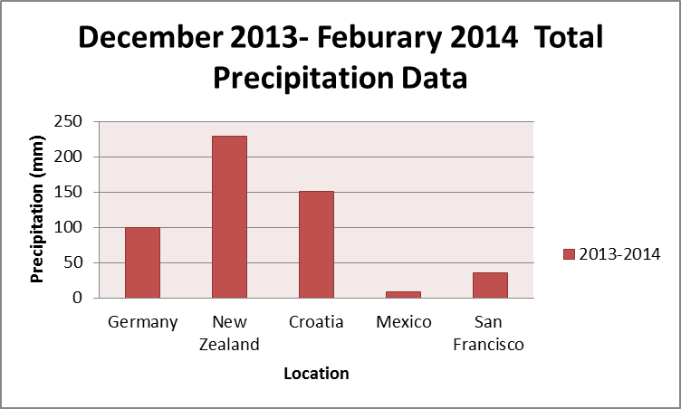**Introduction:** This report as the title suggests, is very similar to the Global Temperature Visualization Data paper. Data for precipitation instead of data for temperature was gathered. A bar graph was chosen to show the amount of precipitation that had occurred in the season of winter in 2013 – 2014. Conveniently, all the data values are in millimeters. These locations were chosen to relate or directly match the observed locations of the last report concerning global temperature. Though, as seen, there is no Saudi Arabia for there is reportedly no rain measured there.

**Global Temperature Visualization Data Table**

**Results Discussion:** The map from <http://vis.globe.gov/GLOBE/#> was useful to determine a country’s locations.The difference of numbers demonstrates the variety of precipitation that occurs around the globe. New Zealand is a land mass located in the southern hemisphere gets quite a bit of precipitation in the winter compared to Mexico which is north of it. Also Croatia, which is below Germany, has more precipitation as well. Then there is San Francisco, this location was used instead of Benicia for the class was not able to find a good set of precipitation data for the small town of Benicia. San Francisco and Benicia are both part of the San Francisco Bay Area, thus giving us a good substitute for the location of Benicia. Note, a significant portion of Saudi Arabia has no rainfall, thus it was not graphed. Other things to notice in this visualization report is that, the total values recorded in this report may not necessarily represent the average winter precipitation observed for that country. Some measurements may have been conducted near the coast where rain may have been more prevalent and possibly other measurements may have been taken in a dryer part of the country. Though this report’s locations is not very specific, it can give you somewhat of a general overview of the different precipitation measurements taken in different parts of the globe.