**Global Humidity Visualization Data**

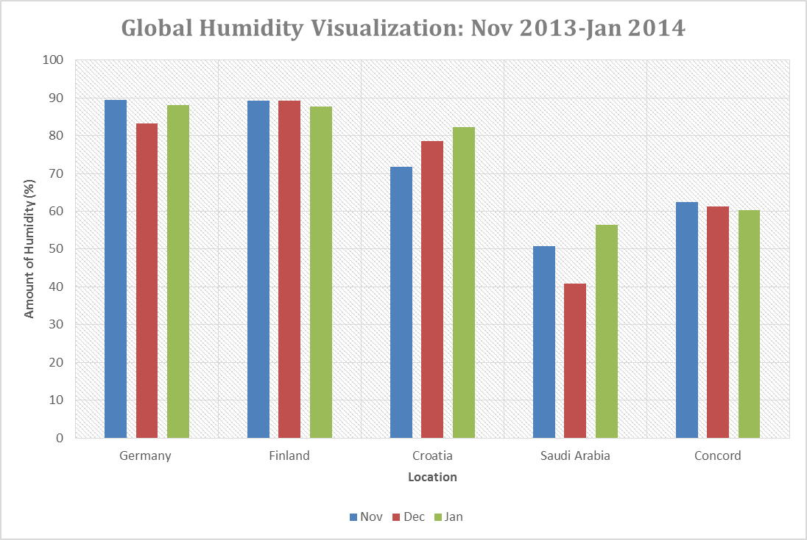**Introduction:** The ECH20 Academy of juniors decided to research humidity in different parts of the world. Germany, Finland, Croatia, Saudi Arabia, and Concord, CA in the U.S. were the chosen locations. Concord, CA was selected as a substitute for Benicia, CA because humidity data for Benicia was not quickly accessible in a digital format. Concord is a good choice as a substitute for it is located in the San Francisco Bay Area, the same place where Benicia is found. Like the previous “Global… Visualization” reports by ECH20 the website globe.gov was used and for this report the source of Concord’s data is: http://www.wunderground.com/history/airport/KCCR/2013/1/3/CustomHistory.html?dayend=3&monthend=1&yearend=2014&req_city=NA&req_state=NA&req_statename=NA. These were the selected locations for the class tried to keep the similar locations with the previous Global Visualization reports produced by the academy. It was decided that the class was to submit a report with a bar graph with monthly averages; the time range is similar to that of the “Global Precipitation Visualization Data” report. The months chosen were November, December, and January; this data helps us to visualize humidity levels in the Autumn-Summer season around the world.

**Global Humidity Visualization Data Table**

**Results Discussion:** Germany and Finland seem to be the most humid countries amongst the target locations. Around this time of the year these two European countries are reaching the measurements of about 90% humidity. As the graph is observed, Croatia manifests an ascending staircase like appearance; these months record Croatia’s humidity level as steadily climbing. Interestingly on the other side of the graph and the globe – Concord’s humidity level within the measured months is steadily declining. Meanwhile Saudi Arabia’s humidity in those months seems to be unlike that of Croatia’s steady climb or Concord’s steady descend. Croatia results around 70% - 83% for humidity, similar to Germany and Finland but lower. Saudi Arabia with its heated land of course contains the lowest readings that measure up to around 50%. The second lowest location concerning humidity levels is Concord, averaging about 60%. These differences demonstrate and help visualize the different humidity patterns and readings that can be found in different parts of the world around the cooler part of the year.